# In[8]:

**import numpy as np**

**import pandas as pd**

# In[9]:

content = pd.read_csv('agri.csv')

Content

**Output:**

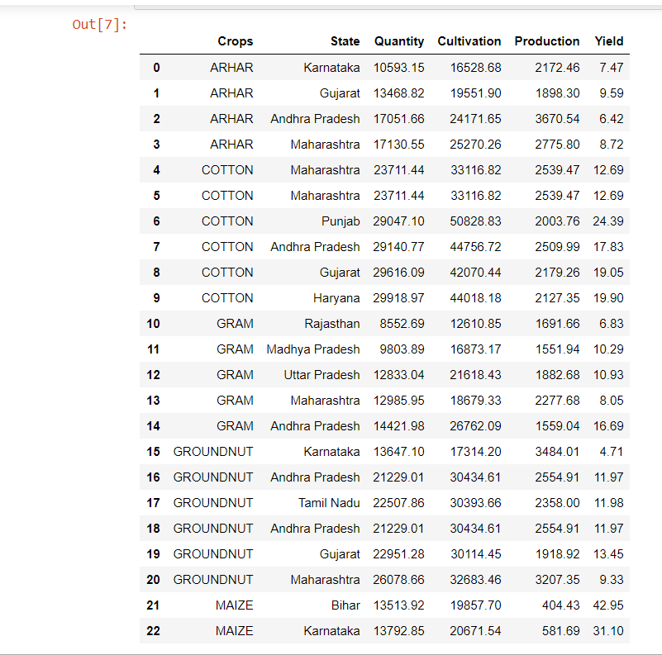

# In[6]:

type(content)

**output:**

pandas.core.frame.DataFrame

# In[7]:

content.head()

**output:**

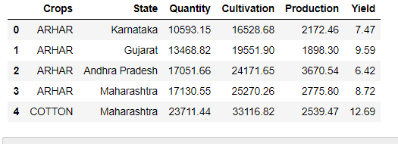

# In[8]:

content.tail()

**output:**

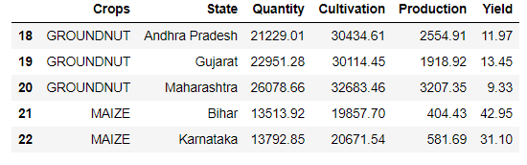

#”RENAME THE COLUMN NAME”

# In[10]:

content = content.rename(columns={'Crops':'INCrops'})

content.head(5)

**Output:**

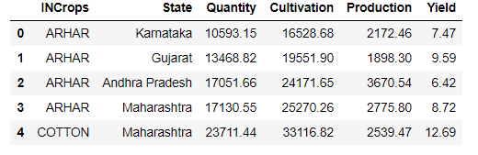

#“RETRIVE SPECIFIC VALUE ITEMS”

# In[19]:

single_State = content[content.State == 'Maharashtra']

single_State

**Output:**

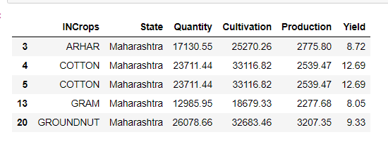

#”RETRIVE SINGLE COLUMN”

# In[29]:

single_column = content.INCrops

single_column

**Output:**

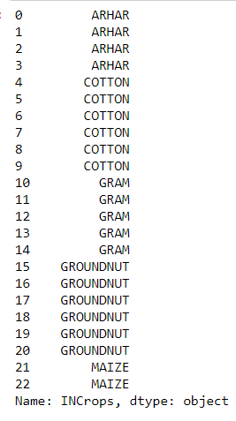

#”RETRIVE MULTIPLE COLUMNS”

# In[32]:

more_columns = content[{'State','Yield'}]

more_columns

**Output:**

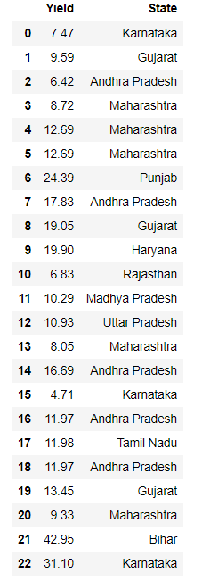

#“RETRIVING VALUES USING SPECIFIC LOCATION”

# In[36]:

content.loc [{2,5},'Production']

**Output:**

2 3670.54

5 2539.47

Name: Production, dtype: float64

# In[41]:

content.loc[2:7,{'Production','INCrops','State'}]

**Output:**

|  | **Production** | **State** | **INCrops** |
| --- | --- | --- | --- |
| **2** | 3670.54 | Andhra Pradesh | ARHAR |
| **3** | 2775.80 | Maharashtra | ARHAR |
| **4** | 2539.47 | Maharashtra | COTTON |
| **5** | 2539.47 | Maharashtra | COTTON |
| **6** | 2003.76 | Punjab | COTTON |
| **7** | 2509.99 | Andhra Pradesh | COTTON |

“RETRIVING VALUES USING INDEX OF THE LOCATION”

# In[43]:

content.iloc[2:7,1:3]

**Output:**

| **State** | **Quantity** |
| --- | --- |
| **2** | Andhra Pradesh | 17051.66 |
| **3** | Maharashtra | 17130.55 |
| **4** | Maharashtra | 23711.44 |
| **5** | Maharashtra | 23711.44 |
| **6** | Punjab | 29047.10 |

# In[51]:

content.describe()

**Output:**

|  | **Quantity** | **Cultivation** | **Production** | **Yield** |
| --- | --- | --- | --- | --- |
| **count** | 23.000000 | 23.000000 | 23.000000 | 23.000000 |
| **mean** | 18997.270870 | 27907.756522 | 2193.200870 | 14.304348 |
| **std** | 6912.965828 | 10228.488536 | 769.114528 | 8.790868 |
| **min** | 8552.690000 | 12610.850000 | 404.430000 | 4.710000 |
| **25%** | 13491.370000 | 19704.800000 | 1890.490000 | 9.025000 |
| **50%** | 17130.550000 | 26762.090000 | 2179.260000 | 11.970000 |
| **75%** | 23711.440000 | 32900.140000 | 2547.190000 | 17.260000 |
| **max** | 29918.970000 | 50828.830000 | 3670.540000 | 42.950000 |

# In[52]:

**import matplotlib.pyplot as plt**

**get_ipython().run_line_magic('matplotlib', 'inline')**

**“LINE PLOT”**

# In[60]:

plt.plot(content.Quantity, content.Production)

plt.xlabel('Quantity')

plt.ylabel('Production')

plt.show()

**Output:**

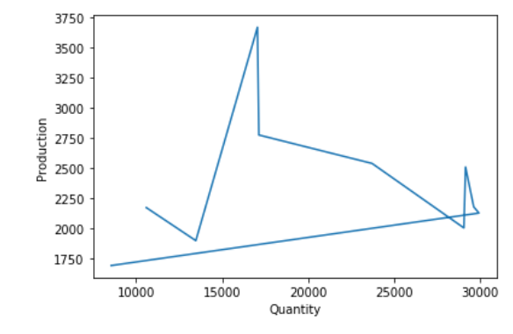

“REDUCING THE DATASET”

# In[54]:

content=content.iloc[0:11 ,0:6]

content.head(11)

**Output:**

| **INCrops** | **State** | **Quantity** | **Cultivation** | **Production** | **Yield** |
| --- | --- | --- | --- | --- | --- |
| **0** | ARHAR | Karnataka | 10593.15 | 16528.68 | 2172.46 | 7.47 |
| **1** | ARHAR | Gujarat | 13468.82 | 19551.90 | 1898.30 | 9.59 |
| **2** | ARHAR | Andhra Pradesh | 17051.66 | 24171.65 | 3670.54 | 6.42 |
| **3** | ARHAR | Maharashtra | 17130.55 | 25270.26 | 2775.80 | 8.72 |
| **4** | COTTON | Maharashtra | 23711.44 | 33116.82 | 2539.47 | 12.69 |
| **5** | COTTON | Maharashtra | 23711.44 | 33116.82 | 2539.47 | 12.69 |
| **6** | COTTON | Punjab | 29047.10 | 50828.83 | 2003.76 | 24.39 |
| **7** | COTTON | Andhra Pradesh | 29140.77 | 44756.72 | 2509.99 | 17.83 |
| **8** | COTTON | Gujarat | 29616.09 | 42070.44 | 2179.26 | 19.05 |
| **9** | COTTON | Haryana | 29918.97 | 44018.18 | 2127.35 | 19.90 |
| **10** | GRAM | Rajasthan | 8552.69 | 12610.85 | 1691.66 | 6.83 |

# In[62]:

plt.plot(content.Production, content.Quantity)

plt.xlabel('Production')

plt.ylabel('Quantity')

plt.show()

**Output:**

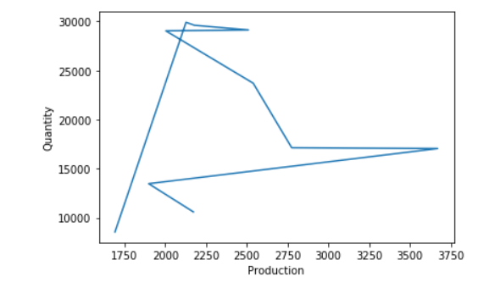

“HISTOGRAM”

# In[74]:

plt.hist(content.Yield)

plt.xlabel('Yield')

plt.ylabel('Frequency')

plt.title('Yield of Agricultural Crops in India')

plt.show()

**Output:**

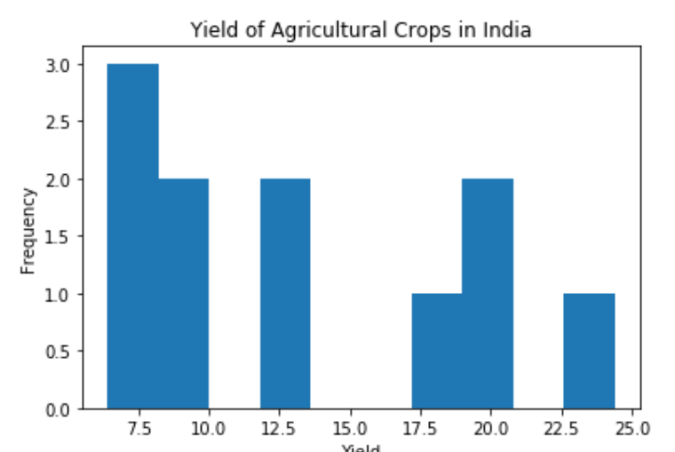

“SCATTER PLOT”

# In[82]:

plt.scatter(content.State,content.Cultivation)

plt.xlabel('State')

plt.ylabel('Cultivation')

plt.title('Scatter plot of production and cultivation')

plt.xticks(rotation=90)

plt.show()

**Output:**

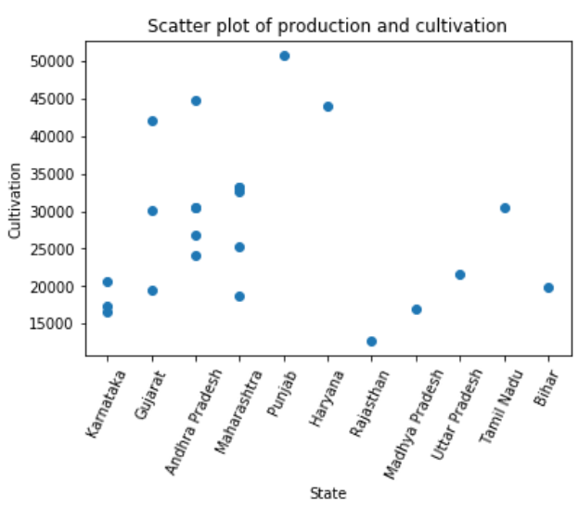

#In[85]:

data = pd.read_csv('agri.csv')

fig,axs = plt.subplots(figsize=(10,6))

crop_wise_yield = data.groupby(['Crops']).sum()['Yield']

plt.plot(crop_wise_yield)

crop_wise_production = data.groupby(['Crops']).sum()['Production']/10

plt.plot(crop_wise_production)

plt.xticks(rotation ='vertical')

plt.legend()

Out[85]:<matplotlib.legend.Legend at 0x1452c701688>

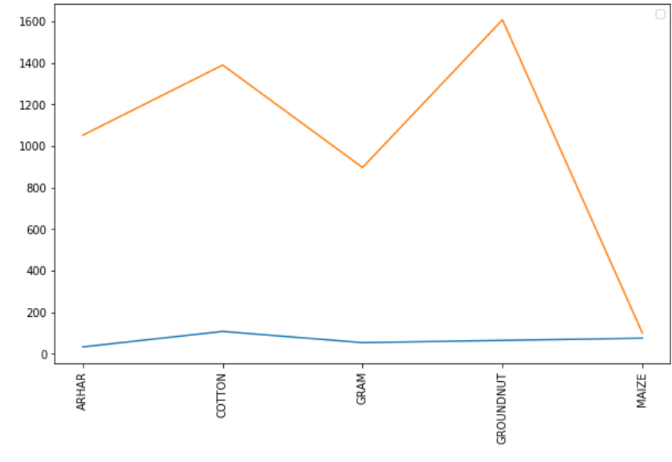

#In[90]:

state_crop_cult = data.groupby(['State'])

index = list(state_crop_cult.indices.keys())

state_crop_cult.sum()[['Production', 'Cultivation']].plot(kind='bar',figsize=(12,7))

Output:

<matplotlib.axes._subplots.AxesSubplot at 0x1452dcdb3c8>

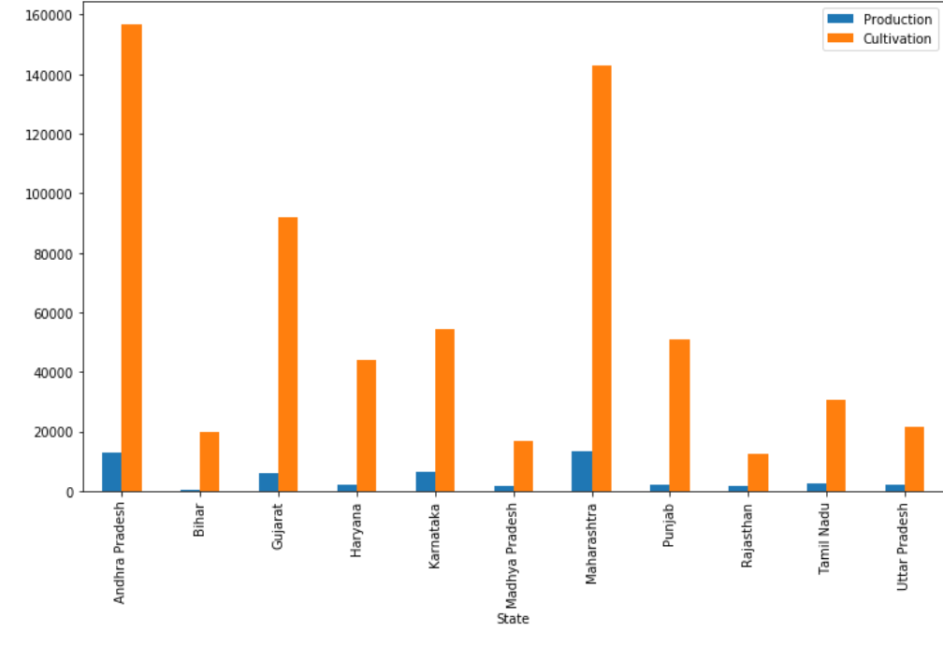

#In[95]:

dataframe = data.groupby('Crops').sum().plot(kind='bar',figsize=(15,7))

dataframe

Output:

<matplotlib.axes._subplots.AxesSubplot at 0x1452dd0f1c8>

